PRESS RELEASE
FOR IMMEDIATE DISTRIBUTION

SOUTH SHORE FURNITURE INCREASES ITS PRESENCE IN THE BABY CATEGORY

Sainte-Croix, March 31, 2020 – South Shore Furniture, a Canadian ready-to-assemble furniture manufacturer, is expanding its nursery product offer and turning into a go-to brand for baby furniture.
“Future moms are requesting more storage configurations in the nursery to meet their specific needs,” said Nicole Basenach, VP Consumer Experience at South Shore Furniture, “so we’ve listened to them and developed a dozen innovative changing tables over the last year. Of course, style and price remain important, so we made sure these additions fit within the soon-to-be parents’ budget and reflect the latest trends.”
South Shore Furniture designed these new items with consumers’ wishes in mind, and came up with fashionable items in the Bohemian, Farmhouse, and Scandinavian styles. The furniture had to be as functional as it was good looking, and made for real life. South Shore’s newer products include narrow changing tables in the Balka collection, meant to save space in smaller rooms. The genuine leather handles add a distinctive little touch that people love in Bohemian décor. Durability was also top of mind with the Admiral changing table, which converts into a double dresser, ideal for a kid’s room, when the top is removed.

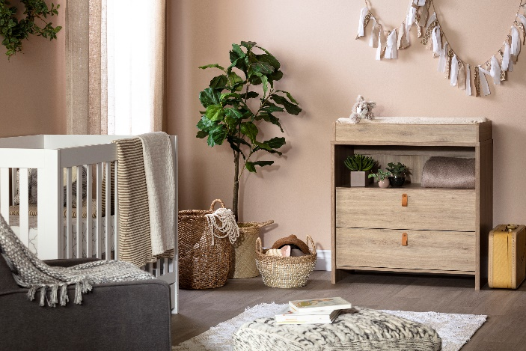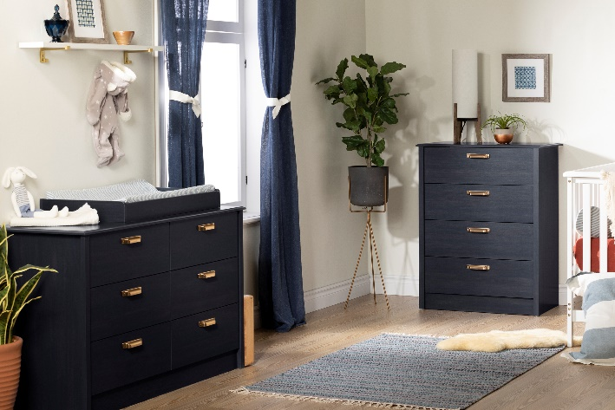

Along with its changing tables, the company has recently added new cribs, dressers, and complementary products, and will continue to expand its baby furniture category. South Shore will soon launch new two-tone Scandinavian cribs in the Balka collection, and three bedding sets made of 100% cotton muslin with unisex patterns – a look particularly prized by moms.

ABOUT SOUTH SHORE
Founded in 1940, South Shore Furniture was the first Canadian manufacturing company to specialize in online furniture sales. Its success rests on a team of nearly 1000 employees who work in seven different locations across North America.
Designing furniture that’s made for real life is a shared passion at South Shore Furniture. That’s why South Shore continues to surprise with new products adapted to consumers’ needs. The company offers more than 1300 pieces of furniture and decorative items, each one of them trendy and affordable.
To cap it all off, this Quebec-based business is one of Canada’s Best Managed Companies (bestmanagedcompanies.ca).

FOR INFORMATION AND INTERVIEWS :
Nicole Basenach, Vice-president Consumer Experience
nbasenach@southshorefurniture.com
Tél. 418 570-0497
www.southshorefurniture.com

