Press Release:

Malarkey Kids Recognized as JPMA Innovation Awards Finalists

in Two Categories for Two Different Products
Finalists Represent the Year’s Most Innovative Baby & Children’s Products
Burlington — Malarkey Kids is pleased to announce that its Crib Chomper Teething Crib Rail Guard and the Munch Mitt Sensory Silicone Teething Mitten are finalists for the 2020 JPMA Innovation Awards. The highly acclaimed competition honors some of the most exciting new baby and children’s products on the market today, including high-tech gear, interactive toys, mind-blowing apps and life changing safety gear.
The NEW Crib Chomper Teething Crib Rail Guard is a finalist in the “Safety” category while its sister teething product, the Munch Mitt Sensory Silicone Teething Mitten, is a finalist in the “Tried and True” category.

“We are honored to be recognized as Innovation Award finalists by JPMA with not one but two products, which is strong validation that Malarkey Kids continues to create innovative and original products proven to fill a gap in the juvenile product market,” said Melissa Hyslop, President and CEO, Malarkey Kids.

The mom of three boys credits her sons as her source of inspiration, “My first son could not stop chewing on his hands when he was teething, which inspired me to create the original teething mitten, the Munch Mitt. My second son seemed to be in beaver mode constantly making a meal out of his crib rail. Therefore, I needed to create a product that would product a baby’s sore gums, incoming teeth as well as protect a baby from ingesting pieces of the crib while maintaining the integrity of the crib. And that’s how the Crib Chomper idea came to be!”

The Munch Mitt is a fun and convenient teething solution that protects baby’s hands from chewing; prevents the constant dropping of teething toys and aids young infants in accessing pain relief easily. This sensory teething mitt consists of a food-grade silicone teether, a stimulating visual pattern and makes crinkly sounds. The Munch Mitt retails at $12.99 USD.
In addition to protecting baby from ingesting paint, wood as well as from damaging little teeth and gums, it features soft, padded, drool absorbent fabric + a layer of textured, chewy food-grade silicone to protect both baby and crib. The Crib Chomper fits most standard and convertible crib rails. The 1-piece Crib Chomper retails at $29.00 USD and the 3-piece Crib Chomper retails at $45.00 USD.

Hyslop added, “Although the complete Crib Chomper line won’t be available until September 2020, Malarkey Kids could not miss the opportunity to participate in The JPMA Innovation Awards process. It’s an annual opportunity to demonstrate our commitment to developing and promoting safe and functional products within the juvenile industry.”
The winners will be announced at 9:00 a.m. on Wednesday, April 1, 2020. Award winners will be selected by an esteemed lineup of judges, including top names in media and safety, in 13 distinct categories, including a new “Tried and” True category that honors products on the market for five years or longer.

In addition to the category winners, two additional top awards will be announced, “Parents Pick” and “Best in Show.” The Crib Chomper is also nominated for the “Parents Pick” award, which is chosen by parents across the country. Voting for the “Parents Pick” award is now live and ends March 30th at noon via https://www.jpma.org/general/custom.asp?page=parents-pick . The “Best in Show” award goes to the product with the highest overall score, regardless of category.
“The JPMA Innovation Awards are a testament to the level of innovation in our industry,” said Kelly Mariotti, JPMA’s executive director. “This year’s finalists have made important advancements in quality and safety for baby and children’s products that will help make parents lives easier, and give them added peace of mind.”
###
ABOUT MALARKEY KIDS
Malarkey Kids is celebrating its five-year anniversary in 2020!
In 2015, Melissa Hyslop started selling her invention, the original teething mitten, the Munch Mitt, from her basement in a two-person pick-and-pack sales operation. Fast forward to today and Malarkey Kids employs ten people and its headquarters is in a 2,000 square foot office with a 4,300 square foot warehouse (and that's only for products sold in Canada). Collectively, Malarkey Kids products are sold in over 5,000 stores in NA and in over 50 countries. Three babies and five years later, Melissa continues to create award-winning teething products for babies (and parents) around the world!
ABOUT THE INNOVATION AWARDS
The Innovation Awards competition began in 1989 as the Most Innovative Product Contest and has become recognized as a highly acclaimed competition. In 2003 JPMA renamed it as the Innovation Awards to more accurately represent the focus on innovation.
ABOUT JPMA
The Juvenile Products Manufacturers Association (JPMA) is the voice of the industry on quality and safety for baby and children’s products. We do this by:
- Advocating for safety through product certification programs and legislative and regulatory involvement;
- Supporting a broad and diverse membership through member-only programming and industry promotion;
- And by acting as a comprehensive source for baby product information and education.
JPMA members represent 95 percent of the prenatal to preschool products sold in North America.
To find out more about JPMA, our certification program and products certified, and for a complete listing of JPMA members, please visit www.jpma.org. Follow JPMA on Twitter @JPMA and connect with us on Facebook to learn about additional safety tips and JPMA initiatives.

For information, including high resolution images and video, please contact:
Tanya Bragg, PR and Social Media Manager
Malarkey Kids Inc.
E: PR@MalarkeyKids.com Ph: 289-260-0765
www.MalarkeyKids.com

Floral Crib Chomper Teething Crib Rail Guard
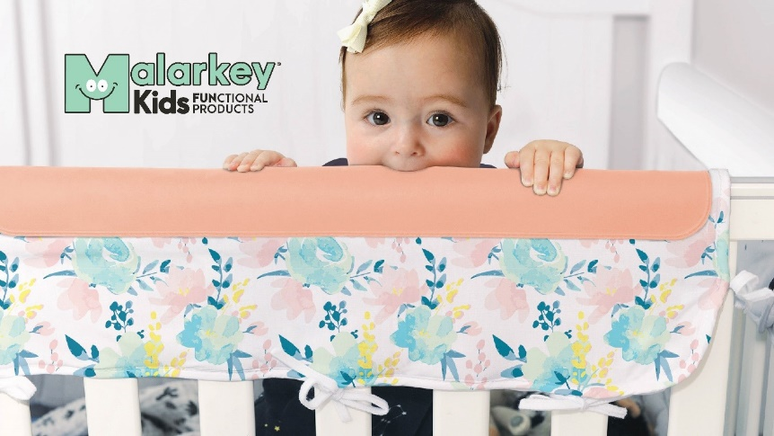

Features of the Crib Chomper Teething Rail Guard
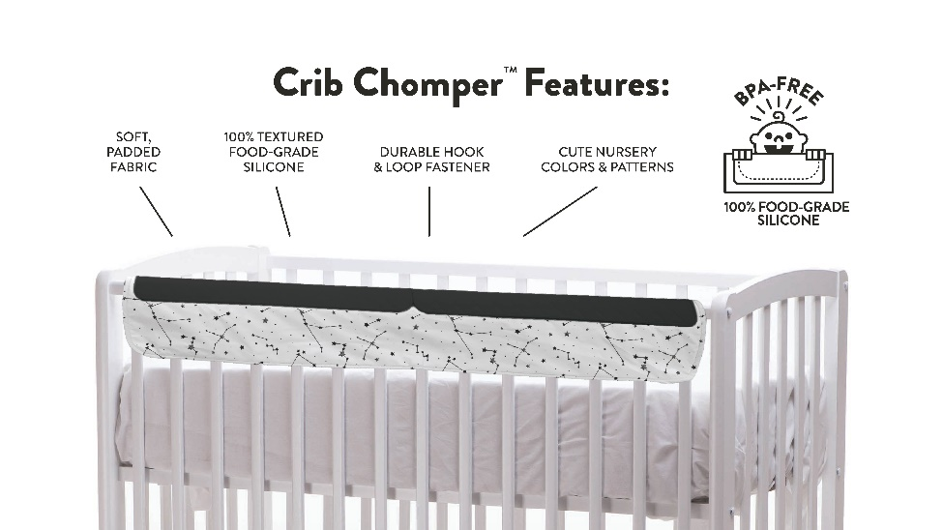

Different Patterns in the collection
