Get Your MOOV On: A Sleek Bag for Parenting and Beyond

Heading out the door with a new baby can feel as if you are preparing for a week-long camping trip.
MOOV, the do-almost-everything bag, aims to simplify busy parents’ lives.
We are parents. And we are engineers. So we designed and produced a bag to make parenting easier. Then we re-designed it to make it a bag for a lifetime. It has gained notice, including a designation as a JPMA Innovation Award finalist.
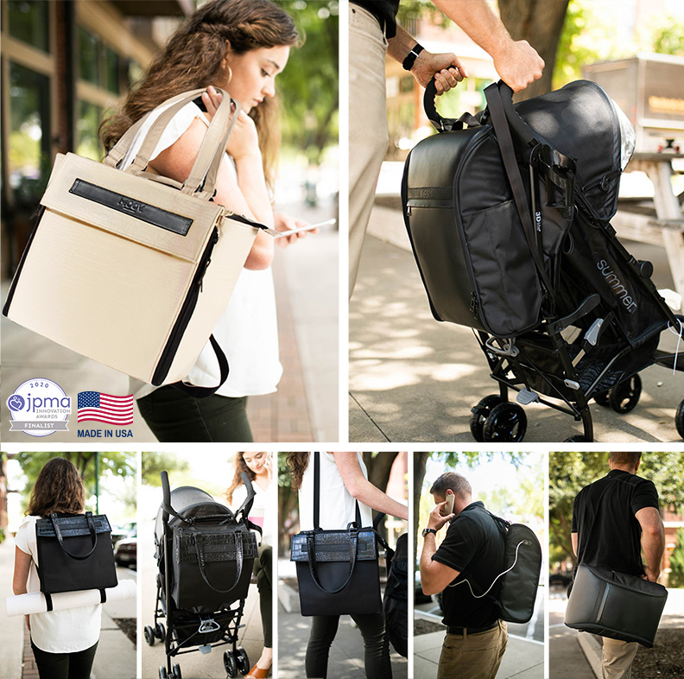
Our Made in the USA product tastefully combines fashion and function into one minimalist luxury bag, from diaper bag to a baby changing station, a computer bag, a travel bag and more. MOOV’s unique design has compartments for all baby necessities and a patented xCheck checklist system – the virtual indicator that reminds parents of important necessities. This smart-pocket feature helps parents delegate care confidently to other family members or outside help.
MOOV’s organization system also reduces the time parents spend looking for a clean outfit or pacifier. When cleanliness is a concern and you need to perform diaper switches on-the-go, the MOOV built-in changing station comes with a machine-washable pad to offer a sanitary and convenient surface to change a diaper.
As the children grow, their needs change and parents’ needs change. MOOV accessories make it easy to tailor the MOOV bag to fit a new dynamic. Pack your laptop, phone, or makeup … MOOV is intuitive and helpful with room for parent items, too.
Did you ask about versatility? MOOV easily can convert to different styles to meet each parent's needs –from handbag, to shoulder bag, to backpack, to messenger bag and everything in between. It comes in two styles, one designed for fashion-forward moms and one that is dad-friendly.

Join us. Let’s MOOV…together.

