FOR IMMEDIATE RELEASE

GRYPH & IVYROSE RELEASES CHILDREN’S BOOK, “THE LOST ELEPHANT”
Pediatrician Dr. Stephen Cowan, MD Presents Story Emphasizing the Importance of Every Child’s Gifts
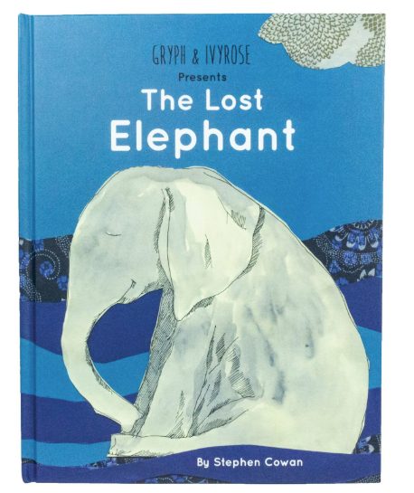

Miami, FL (October 2019) — Gryph & IvyRose, a wellness brand of high performance herbal and immune-supporting products for children, presents the release of its first children’s book, “The Lost Elephant.” Written and Illustrated by Gryph & IvyRose Pediatrician, Dr. Stephen Cowan, MD, the story accentuates the brand’s ideals of caring for each child’s individual strengths.

The whimsical tale starts with its title character stranded at sea and in need of help from his animal friends; a gorilla, owl, lion, penguin and a peacock who all have their own unique set of skills that work best together. Teaching children how their individual perspective can assist with the success of a group, the book reflects the Gryph & IvyRose approach to parenting in a holistic manner. Dr. Cowan crafted the illustrations through layered artwork and are evocative of the wild animals seen on Gryph & IvyRose’s products.

“This book introduces children to the ancient wisdom of the Five Powers that date back to ancient China,” said author and illustrator Dr. Stephen Cowan, MD. “I hope this book will inspire children to discover their own unique power and how to grow it through relationship with others.”

Dr. Stephen Cowan, MD developed this tale for the modern age to share his holistic approach to evaluating and treating children struggling with chronic physical, emotional and cognitive disorders. He integrated the principles of Chinese medicine and homeopathy through the five powers, represented by the seasons that function together in nature; including Spring—wood “the brave explorer,” Summer—fire “the cheerleader,” Harvest—earth “the peacemaker,” Autumn—gold “the noble judge” and Winter—water “the wise sage.” Using each animal as a symbol for different inherent abilities, the story not only captures children’s attention but also encourages growth and to seek companionship.

“The Lost Elephant” is available for $24.95 on the Gryph &IvyRose ecommerce site, gryphandivyrose.com. 10% of proceeds will be donated to Tournesol Kids, a nonprofit founded by Dr. Cowan to empower children through online education, workshops and community outreach.

Stephen Cowan MD is a board certified pediatrician and artist who has been inspired by the many children he has worked with over the past 30 years. He specializes in Child Development and is the author of Fire Child, Water Child: How Understanding the Five Types of ADHD Can Help You Improve Your Child’s Self-Esteem and Attention. Dr. Cowan has developed a unique holistic approach to supporting each child’s growth by integrating the holistic principles of Five Phase Chinese medicine into his practice. He teaches internationally and has a consultation practice in NY. Dr. Cowan is the medical director of the non-profit Tournesol Kids that envisions a world where all children are heroes, inspired to grow and discover wellbeing by celebrating their unique powers and learning to share them with the world.

About Gryph & IvyRose
After seeking out what we thought were the most natural and healthy product offerings, we realized most options came up short in one department or the other. We wanted to craft a diverse product line that would support the body’s immune function, present high performance and lasting results as well as offer multiple ongoing regimens to address the different challenges our children face. Our commitment to enhancing children’s lives with wellness in a sustainable, accessible and prestigious way began and Gryph & IvyRose was formed. For more information, please visit: www.gryphandivyrose.com

###

